**e-Portfolio Link:** [**https://narunanthy74.github.io/ePortfolio/**](https://narunanthy74.github.io/ePortfolio/)

**GitHub Link:** [**https://github.com/narunanthy74/ePortfolio**](https://github.com/narunanthy74/ePortfolio)

**Section 1: Learning Outcomes:**

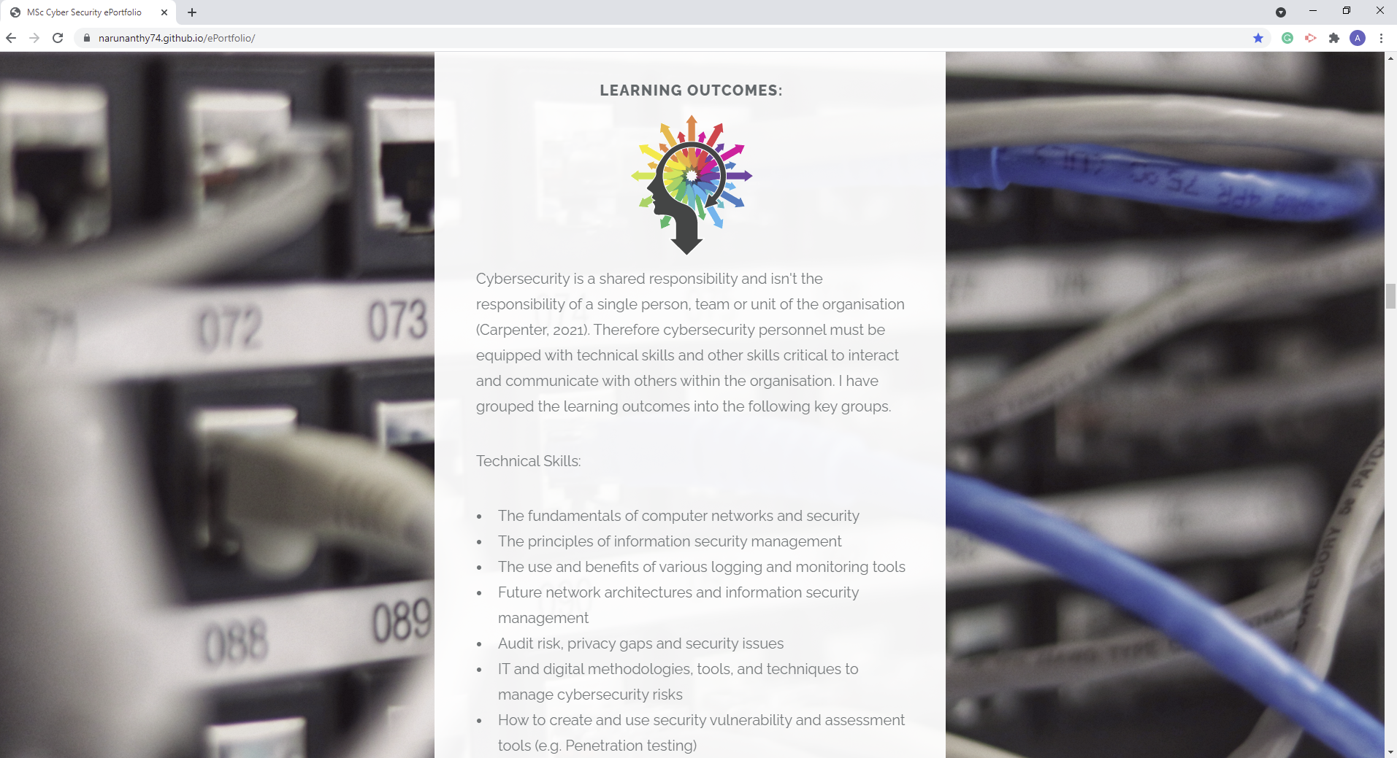

Cybersecurity is a shared responsibility and isn't the responsibility of a single person, team or unit of the organisation (Carpenter, 2021). Therefore cybersecurity personnel must be equipped with technical skills and other skills critical to interact and communicate with others within the organisation. I have grouped the learning outcomes into the following key groups.

Technical Skills:

* The fundamentals of computer networks and security
* The principles of information security management
* The use and benefits of various logging and monitoring tools
* Future network architectures and information security management
* Audit risk, privacy gaps and security issues
* IT and digital methodologies, tools, and techniques to manage cybersecurity risks
* How to create and use security vulnerability and assessment tools (e.g. Penetration testing)
* Identify and analyse security risks and vulnerabilities in IT network systems
* Systematic analysis of security breaches and issues using multiple sources
* Legal and regulatory, social, ethical and professional requirements and expectations

Other Skills:

* Project management (e.g. time management, resources management and quality management)
* Resilience
* Critical thinking and analysis
* Problem-solving
* Communication and literacy skills
* Interpersonal
* Teamwork/global citizen and leadership
* Emotional Intelligence
* Entrepreneurial
* Present critical arguments for specific actions or outcomes
* Critical reflection and evaluation

**Section 2: Artefacts**

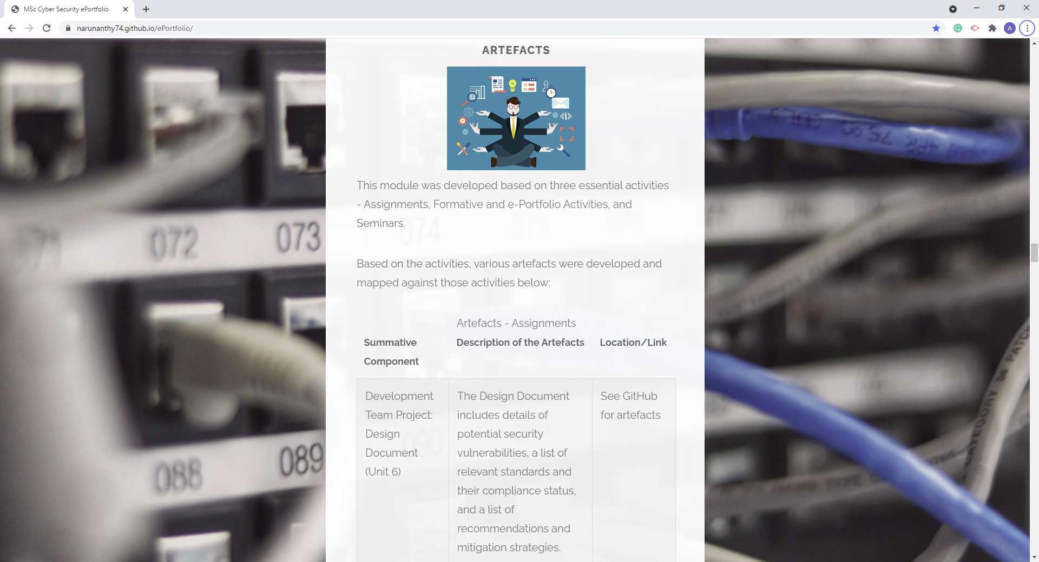

This module was developed based on three essential activities - Assignments, Formative and e-Portfolio Activities, and Seminars. Based on the activities, various artefacts were developed and mapped against those activities below:

|  |  |  |
| --- | --- | --- |
| **Artefacts - Assignments** | | |
| **Summative Component** | **Description of the Artefacts** | **Location/Link** |
| Development Team Project: Design Document (Unit 6) | The Design Document includes details of potential security vulnerabilities, a list of relevant standards and their compliance status, and a list of recommendations and mitigation strategies. | See GitHub for artefacts: <https://github.com/narunanthy74/ePortfolio/tree/main/Artefacts/Assignments> |
| Development Team Project - Executive Summary (Unit 11) | The Executive Summary includes a summary of the work executed concerning the website, finding details presented in an executive summary format, evaluation results against two security standards, recommendations and conclusions. | See GitHub for artefacts: <https://github.com/narunanthy74/ePortfolio/tree/main/Artefacts/Assignments> |
| Individual Module e-Portfolio (Unit 12) | This is the final deliverable – a learning and development e-portfolio. | See GitHub for artefacts: <https://github.com/narunanthy74/ePortfolio/tree/main/Artefacts/Assignments> |

|  |  |  |
| --- | --- | --- |
| **Artefacts - Formative and e-Portfolio Activities** | | |
| **Component** | **Description of the Artefacts** | **Location/Link** |
| Collaborative discussion 1 (Units 1 – 3) | The summary post of Collaborative discussion 1 includes critical threats and vulnerabilities highlighted in the paper and mitigation strategies against those. | See GitHub for artefacts: <https://github.com/narunanthy74/ePortfolio/tree/main/Artefacts/Formative%20and%20e-Portfolio%20Activities> |
| Practical and Team activity (Unit 3) | This Practical and Team activity deliverable includes information collected by scanning the website using standard tools ping, traceroute, dig and nslookup. | See GitHub for artefacts: <https://github.com/narunanthy74/ePortfolio/tree/main/Artefacts/Formative%20and%20e-Portfolio%20Activities> |
| Collaborative discussion 2 (Units 4 – 6) | The summary post of Collaborative discussion 2 includes several scans performed as part of this activity. | See GitHub for artefacts: <https://github.com/narunanthy74/ePortfolio/tree/main/Artefacts/Formative%20and%20e-Portfolio%20Activities> |
| e-Portfolio activity (Unit 7) | This e-Portfolio activity deliverable includes attributes about Kali Linux and similar tools, including Nessus. | See GitHub for artefacts: <https://github.com/narunanthy74/ePortfolio/tree/main/Artefacts/Formative%20and%20e-Portfolio%20Activities> |
| Scanning exercise and Wiki (Unit 7) | This Scanning exercise and Wiki deliverable include information collected using commonly used tools in Kali Linux. | See GitHub for artefacts: <https://github.com/narunanthy74/ePortfolio/tree/main/Artefacts/Formative%20and%20e-Portfolio%20Activities> |
| Collaborative discussion 3 (Units 8 -10) | The summary post of Collaborative discussion 3 includes the elements of the GDPR that the case study highlights, remediation approach, and potential mitigation steps. | See GitHub for artefacts: <https://github.com/narunanthy74/ePortfolio/tree/main/Artefacts/Formative%20and%20e-Portfolio%20Activities> |

|  |  |  |
| --- | --- | --- |
| **Artefacts - Seminars** | | |
| **Session Title** | **Description of the Artefacts** | **Location/Link** |
| Introductory session and group allocation for Team Project (Unit 1) | The final group contract highlights the group member's approach, roles, and responsibilities to complete the project effectively. | See GitHub for artefacts: <https://github.com/narunanthy74/ePortfolio/tree/main/Artefacts/Seminars> |
| STRIDE and DREAD tools (Unit 2) | The STRIDE and DREAD tools deliverable includes the risks ratings related to the risks discussed in Collaborative Learning Discussion 1. | See GitHub for artefacts: <https://github.com/narunanthy74/ePortfolio/tree/main/Artefacts/Seminars> |
| TCP/IP v ISO/OSI (Unit 4) | The TCP/IP v ISO/OSI deliverable includes feedback to a question comparing the TCP/IP and ISO/ OSI 7-layer model. | See GitHub for artefacts: <https://github.com/narunanthy74/ePortfolio/tree/main/Artefacts/Seminars> |
| Evaluation exercise (Unit 6) | The Evaluation exercise deliverable includes the feedback to numerous questions comparing several penetration testing tools. | See GitHub for artefacts: <https://github.com/narunanthy74/ePortfolio/tree/main/Artefacts/Seminars> |
| Security Standards (Unit 8) | The Security Standards deliverable includes evaluation results of the website against the appropriate standards, appropriate recommendations and assumptions. | See GitHub for artefacts: <https://github.com/narunanthy74/ePortfolio/tree/main/Artefacts/Seminars> |
| Data Breach case study (Unit 10) | The Data Breach case study deliverable includes details about the data breach case study selected. | See GitHub for artefacts: <https://github.com/narunanthy74/ePortfolio/tree/main/Artefacts/Seminars> |
| Debate Vote (Unit 12) | The Debate Vote deliverable includes advantages related to future Internet technology. | See GitHub for artefacts: <https://github.com/narunanthy74/ePortfolio/tree/main/Artefacts/Seminars> |

**Section 3: Reflection**

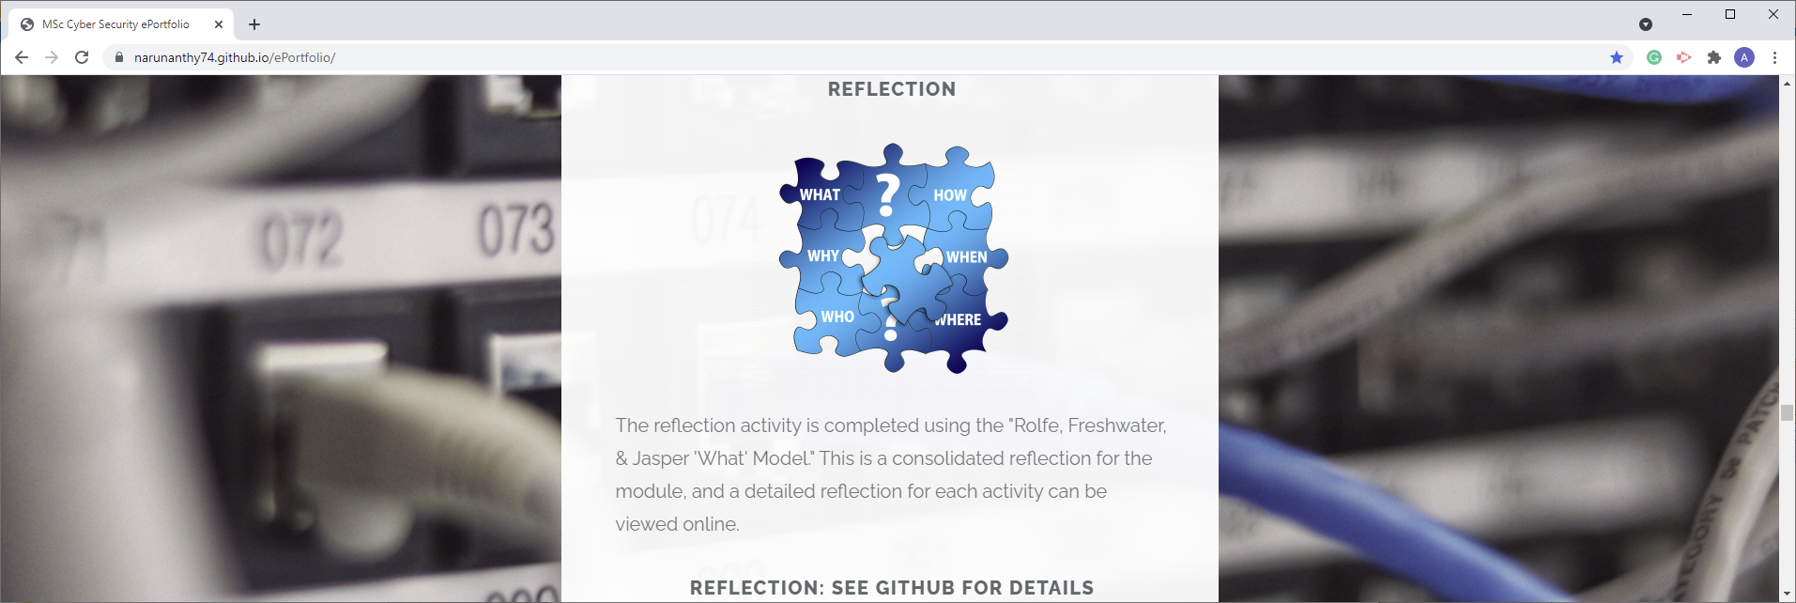

The reflection activity is completed using the "Rolfe, Freshwater, & Jasper 'What' Model." This is a consolidated reflection for the module, and a detailed reflection for each activity can be viewed online.

Consolidated Reflection: <https://github.com/narunanthy74/ePortfolio/tree/main/Reflection>

Detailed Reflection: <https://github.com/narunanthy74/ePortfolio/tree/main/Reflection%20-%20Details>

| **Network and Information Security Management** | | |
| --- | --- | --- |
| **What?** | **So What?** | **What Next?** |
| Three primary activities supported the Network and Information Security Management module: Assignments, Formative and e-Portfolio Activities, and Seminars.  All three of them were integrated in a way that one activity leads to another. For example, the seminar activities helped develop the formative and e-portfolio activities, which led to assignments.  There were seven seminars starting from Introduction to finally a debate. Listed below are the seminars and associated units covered by those seminars:   * Introductory session and group allocation for Team Project (Unit 1) * STRIDE and DREAD tools (Unit 2) * TCP/IP v ISO/OSI (Unit 4) * Evaluation exercise (Unit 6) * Security Standards (Unit 8) * Data Breach case study (Unit 10) * Debate Vote (Unit 12)   There were six formative and e-portfolio activities ranging from analysing papers related to the Medical Mannequin compromise to GDPR. Listed below are the formative and e-portfolio activities and units covered by those activities:   * Collaborative discussion 1 (Units 1 – 3) * Practical and Team activity (Unit 3) * Collaborative discussion 2 (Units 4 – 6) * e-Portfolio activity (Unit 7) * Scanning exercise and Wiki (Unit 7) * Collaborative discussion 3 (Units 8 -10)   There were three assignments targeting topics from scanning the website to e-Portfolio. Listed below are the assignments and units covered by those assignments:   * Development Team Project: Design Document (Unit 6) * Development Team Project - Executive Summary (Unit 11) * Individual Module e-Portfolio (Unit 12)   In addition, students have been guided through 12 modules vis self-learning and supported by various methods, including meeting with the tutor on an as-needed basis. | The formative and e-portfolio activities and seminars helped me learn various skills and apply them effectively.  According to InnerDrive, group work has some limitations and can be highly time-consuming (InnerDrive, N.D.). Initially, I was challenged by mutually agreed time and work distribution for the group activities and engagements. However, the Team Contract helped to address those constraints and enabled us to collaborate effectively.  According to the contract, the work was effectively distributed, monitored by periodic group meetings – at least weekly; feedbacks were provided timely to address any gaps if identified.  Tools and technology were effectively used to collaborate - Google Drive for sharing documents and Discord for discussions and meetings.  Various project management technics, including time, resources and quality management, were applied to complete the deliverables. However, if help was needed, I was ready to help. In addition, understanding others perspectives helped to enhance my knowledge about emotional intelligence. Therefore, I was inspired to help others.  We had an issue with the AWS website during this module, and we couldn't create the website. Alternatively, the group used a different site to complete the activities. Resilience, critical thinking, problem-solving, teamwork and leadership were the learning from this situation.  The deliverables Design Document and Executive Summary development related to the assignments helped advance various skills and technology tools. Primary skills learned by doing these two engagements were critical thinking and analysis, communication and literacy skills, present critical arguments.  Feedback not only helps us to achieve our goals but also transforms us (Barnett, 2020). The input - formal or informal, provided by my group members, class members and tutor helped me develop and improve myself. I was inspired by the feedbacks provided and wanted to do more and accomplish more.  The final seminar related to future trends and technologies, specifically related to the Internet, moved me a lot and helped me learn about other potential Internet technologies.  The development of the e-Portfolio enabled the improvement of the skills related to critical reflection and evaluation.  Technology tools, techniques and processes were a critical internal part of the module. And they were integrated throughout various activities, including self-learning.  Related to computer networks and security, fundamental principles, historical information, various security solutions were key areas covers. In addition, from an ongoing monitoring perspective, identifying and analysing security gaps using multiple sources was also covered.  Associated with security breaches, analysing cases studies about data breaches helped to understand the real-world risks. In addition, these case studies helped to learn assessment methodologies of security breaches and issues using multiple sources. Moreover, social, ethical and professional requirements and expectations were additional learning outcomes from these data breaches.  Leal and regulatory perspective, compliance requirements, assessment methodologies, and remediation strategies – in any gaps identified, were the key learnings. Additionally, potential audit risk, privacy gaps, security issues and reputation issues were essential highlights related to regulatory standards.  **Key Standards Learned:** Essential standards learned during this module are listed below:   * Payment Card Industry Data Security Standard (PCI DSS) * General Data Protection Regulation (GDPR) * Health Insurance Portability and Accountability Act (HIPAA)   **Key Security Tools Learned:**  Shimon Brathwaite, who compared Parrot OS and Kali Linux, considered Kali Linux a "Swiss army knife" of penetration testing (Brathwaite, 2021). Among other tools, Nmap, Wireshark, Burpsuite and Metasploit are a few security tools that come with Kali Linux. Therefore, learning Kali Linux and associated security tools was the key highlight of this module.  Essential security tools learned during this module are listed below:   * Burpsuite * Dig * Dnschecker * GDPR Compliance Test * HPing * HTTP Headers Security Test * Jawfish * Kali Linux * Metasploit * Nessus * Nikto * Nmap * Nslookup * OWASP Zap * PCI DSS Compliance Test * Ping * Security risk assessment models: STRIDE and DREAD * Software Security Test * SQLMap * SSLScan * TCP/IP OSI 7 layer model * Traceroute * Web Server Security Test * Whois * Wireshark | The security tools learned for this module can be utilised for security assessment. I would use the experience gained from this module to identify the appropriate tool effectively. In addition, I will enhance my knowledge by doing additional research and experiments and share with the security community.  I would apply transferable skills such as Interpersonal, Entrepreneurial and leadership effectively. And would actively improve those skills. Among other skills indicated the following skills would be critical for the cybersecurity personnel:   * Project management * Resilience * Critical thinking and analysis * Problem-solving * Communication and literacy skills * Teamwork * Effective Presentation skills   I would actively apply those skills and will enhance them when possible. |

**Section 4: Meeting Notes**

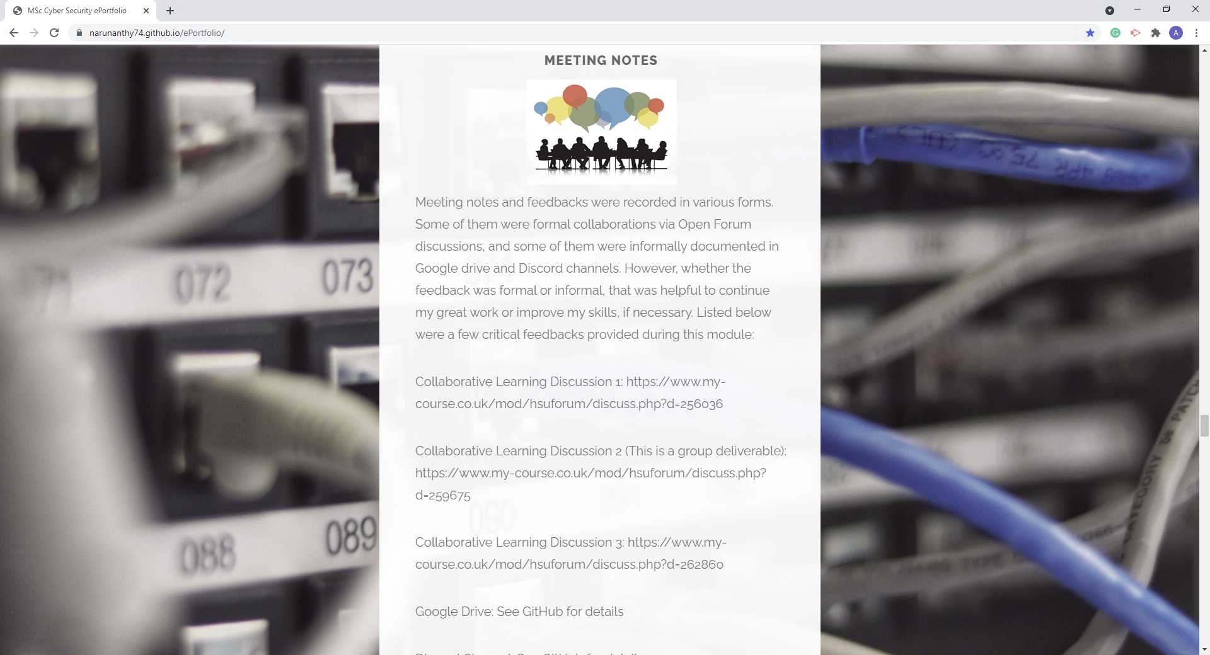

Meeting notes and feedbacks were recorded in various forms. Some of them were formal collaborations via Open Forum discussions, and some of them were informally documented in Google drive and Discord channels. However, whether the feedback was formal or informal, that was helpful to continue my great work or improve my skills, if necessary. Listed below were a few critical feedbacks provided during this module:

Collaborative Learning Discussion 1: <https://www.my-course.co.uk/mod/hsuforum/discuss.php?d=256036>

Collaborative Learning Discussion 2 (This is a group deliverable): <https://www.my-course.co.uk/mod/hsuforum/discuss.php?d=259675>

Collaborative Learning Discussion 3: <https://www.my-course.co.uk/mod/hsuforum/discuss.php?d=262860>

Google Drive: <https://github.com/narunanthy74/ePortfolio/tree/main/Meeting%20Notes>

Discord Channel: <https://github.com/narunanthy74/ePortfolio/tree/main/Meeting%20Notes>

**Section 5: Professional Skills Matrix and Action Plan**

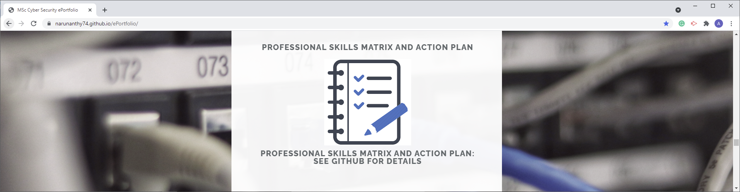

| **Competency** | **Essex Graduate** | **Skill** | **Skill Level** | **Evidence** |
| --- | --- | --- | --- | --- |
| **Professional** | **Literacy, Communication, Language Skills** | Express information effectively to technical and non-technical audiences | Proficient | Demonstrated in the assignment submissions. |
| Create documents to aid your communication (reports, diagrams, legal descriptions, plans, manuals and charts) | Proficient | Demonstrated in the assignment submissions. |
| **Commercial Awareness** | Keep current with tools of the industry, as well as emerging technology | Proficient | Demonstrated during several website scanning activities. |
| Seek opportunities to improve and share knowledge of tools and technology that may improve productivity | Proficient | Demonstrated during several website scanning activities and assignment submissions. |
| Participate in scientific and professional organisations | Proficient | Member of the following international professional organisations:   * The International Information System Security Certification Consortium (ISC)²; * Information Systems Audit and Control Association (ISACA) |
| Emphasise quality, customer satisfaction and proper application of policies. | Proficient | Demonstrated in the assignment submissions. |
| Demonstrate familiarity with codes of conduct for the Computing field. | Proficient | As a member of professional organisations such as (ISC)² and (ISACA), I have demonstrated a good understanding of codes of conduct for the Computing field.  In addition, as part of the data breach case study assessed during a seminar, I have demonstrated this competency. |
| **Subject understanding, research, critical thinking, time management** | Critically analyse complex ideas in concepts in the field of Computer Science | Proficient | As part of case studies assessed during seminars, including case studies related to GDPR noncompliance, I have demonstrated this competency. |
| Recognise inconsistencies and gaps in information, and search for additional information when needed. | Proficient | Same as above |
| Explore complex real-world problems in a Computing context | Proficient | Same as above |
| **Legal and Ethical** | **Ethical Awareness** | Comply with the letter and spirit of applicable laws | Proficient | As a member of professional organisations such as (ISC)² and (ISACA), I have demonstrated a good understanding of laws, regulations and industry standards. |
| Maintain privacy and confidentiality of company, co-worker and customer information | Proficient | As part of a case study related to GDPR noncompliance, I have demonstrated this competency. |
| **Social (inc. Teamwork)** | **Cultural Awareness** | Act in the best interest of the community at large - Social (Community) Responsibility | Proficient | Team contract;  100% Seminar participation; and  100% Group meetings |
| **Teamwork, Leadership and Resilience, Time Management** | Collaborate effectively in diverse teams to achieve team goals | Proficient | Among other team activities, actively participated in collaborative discussions. |
| Meeting team objectives using teamwork skills | Proficient | Team contract;  100% Seminar participation; and  100% Group meetings |
| Demonstrate skills in leadership and team building | Proficient | Same as above |
| Give and receive constructive feedback | Proficient | Among other team activities, actively participated in collaborative discussions. |
| **Creativity, Entrepreneurial, Problem solving, Initiative, Decision Making** | Create, discuss and deliver strategies for sustainability for all stakeholders (company, community and environment) | Proficient | Demonstrated during several website scanning activities and assignment submissions. |
| Able to make a decision on a complex matter/scenario using multiple sources of information | Proficient | During this module, we had an issue related to AWS, and we handled the situation effectively. |
| **Technical (Data Science)** | **IT and Digital, Numeracy** | *Technical skills relevant to the module:* |  | Demonstrated during several website scanning activities and assignment submissions. |
| Burpsuite | Proficient |
| Dig | Proficient |
| Dnschecker | Proficient |
| GDPR Compliance Test | Trained |
| HPing | Proficient |
| HTTP Headers Security Test | Trained |
| Jawfish | Proficient |
| Kali Linux | Proficient |
| Metasploit | Proficient |
| Nessus | Proficient |
| Nikto | Proficient |
| Nmap | Proficient |
| Nslookup | Proficient |
| OWASP Zap | Proficient |
| PCI DSS Compliance Test | Trained |
| Ping | Proficient |
| Security risk assessment models: STRIDE and DREAD | Trained |
| Software Security Test | Trained |
| SQLMap | Proficient |
| SSLScan | Proficient |
| TCP/IP OSI 7 layer model | Proficient |
| Traceroute | Proficient |
| Web Server Security Test | Proficient |
| Whois | Proficient |
| Wireshark | Proficient |
| HyperText Markup Language | Proficient |
| Gits - repository development and maintenance | Proficient |
| Use of conferencing technologies and Moodle (VLE) | Proficient |
| Use of Word Processing tools and Spreadsheets | Proficient |
| Effective use of e-library resources | Proficient |
| **Subject Application** | **Global Citizen, Teamwork, Leadership, Emotional Intelligence** | Take into account other people's perspectives | Proficient | Team contract;  100% Seminar participation; and  100% Group meetings  In addition, among other team activities, I actively participated in collaborative discussions. |
| Work constructively with differences in viewpoints | Proficient | Same as above |
| Actively participate in a range of community activities as an informed citizen | Proficient | As a member of professional organisations such as (ISC)² and (ISACA), I participate in local chapter activities. |
| **Decision Making, Initiative, Emotional Intelligence, Ethical Awareness** | Develop, articulate and clarify your personal values and ethics | Proficient | Among other activities, by participating in local chapter activities, I have demonstrated this competency. |

Action Plan: <https://github.com/narunanthy74/ePortfolio/tree/main/Action%20Plan>

**Skill Level Key**

Aware General understanding and basic knowledge

Trained Able to apply knowledge, able to work independently under certain conditions

Proficient Broad and in-depth knowledge, able to work independently with very little supervision

Expert Seen as a subject matter expert, able to lead and train others.

**References:**

Carpenter, P. (2021) Building a culture of cybersecurity: 3 key takeaways from the 2021 SANS report. Available from: <https://www.securitymagazine.com/articles/95568-building-a-culture-of-cybersecurity-3-key-takeaways-from-the-2021-sans-report> [Accessed 25 July 2021].

InnerDrive. (N.D.) 10 ADVANTAGES AND DISADVANTAGES OF GROUP WORK IN THE CLASSROOM. Available from: <https://blog.innerdrive.co.uk/advantages-disadvantages-group-work> [Accessed 25 July 2021].

Barnett, J. (2020) Feedback Doesn't Just Help Us Perform. It Helps Us Transform. Available from: <https://www.forbes.com/sites/jimbarnett/2020/03/03/feedback-doesnt-just-help-us-perform-it-helps-us-transform/?sh=31698b5360f0> [Accessed 25 July 2021].

Brathwaite, S. (2021) Which is better Parrot OS or Kali Linux?. Available from: <https://www.securitymadesimple.org/cybersecurity-blog/which-is-better-parrot-os-or-kali-linux> [Accessed 25 July 2021].